UCC FINANCING STATEMENT
FOLLOW INSTRUCTIONS (font and back) CAREFULLY
A. NAME & PHONE OF CONTACT AT FILER [optional]

B. SEND ACKNOWLEDGMENT TO: (Name and Address) |  |  |  |  |  |  |  |  | THE ABOVE SPACE IS FOR FILING OFFICE USE ONLY
1. DEBTOR’S EXACT FULL LEGAL NAME – insert only one debtor name (1a or 1b) – do not abbreviate or combine names

OR | 1a. ORGANIZATION’S NAME
OR | 1b. INDIVIDUAL’S LAST NAME |  |  |  |  |  |  | FIRST NAME |  | MIDDLE NAME |  |  | SUFFIX
1c. MAILING ADDRESS |  |  |  |  |  |  |  | CITY |  | STATE |  | POSTAL CODE | COUNTRY
1d. SEE INSTRUCTIONS |  |  | ADD’L INFO RE  ORGANIZATION  DEBTOR |  | 1e. TYPE OF ORGANIZATION |  |  | 1f. JURISDICTION OF ORGANIZATION |  | 1g. ORGANIZATION ID#, if any |  |  |  | NONE
2. ADDITIONAL DEBTOR’S EXACT FULL LEGAL NAME – insert only one debtor name (1a or 1b) – do not abbreviate or combine names

OR | 2a. ORGANIZATION’S NAME
OR | 2b. INDIVIDUAL’S LAST NAME |  |  |  |  |  | FIRST NAME |  |  | MIDDLE NAME |  |  | SUFFIX
2c. MAILING ADDRESS |  |  |  |  |  |  | CITY |  |  | STATE |  | POSTAL CODE | COUNTRY
2d. SEE INSTRUCTIONS |  |  | ADD’L INFO RE  ORGANIZATION  DEBTOR | 2e. TYPE OF ORGANIZATION |  |  | 2f. JURISDICTION OF ORGANIZATION |  |  | 2g. ORGANIZATION ID#, if any |  |  |  | NONE
3. SECURED PARTY’S NAME (or NAME of TOTAL ASSIGNEE or ASSIGNOR S/P) – insert only one secured party name (3a or 3b)

OR | 3a. ORGANIZATION’S NAME
OR | 3b. INDIVIDUAL’S LAST NAME |  |  |  |  |  | FIRST NAME |  |  | MIDDLE NAME |  |  | SUFFIX
3c. MAILING ADDRESS |  |  |  |  |  |  | CITY |  |  | STATE |  | POSTAL CODE | COUNTRY
4. This FINANCING STATEMENT covers the following collateral:

5. ALTERNATIVE DESIGNATION [if applicable]: LESSEE/LESSOR CONSIGNEE/CONSIGNOR BAILEE/BAILOR SELLER/BUYOR AG. LIEN NON-UCC FILING
6. |  | This FINANCING STATEMENT is to be filed [for record] (or recorded) in the REAL ESTATE RECORDS. Attach Addendum [if applicable] |  |  |  | 7. Check to REQUEST SEARCH REPORT(S) on Debtor(s)  [ADDITIONAL FEE] [optional] |  |  |  |  | All Debtors Debtor 1 Debtor 2
8. OPTIONAL FILER REFERENCE DATA

FILING OFFICE COPY – NATIONAL UCC FINANCING STATEMENT (FORM UCC1) (REV. 05/22/02)

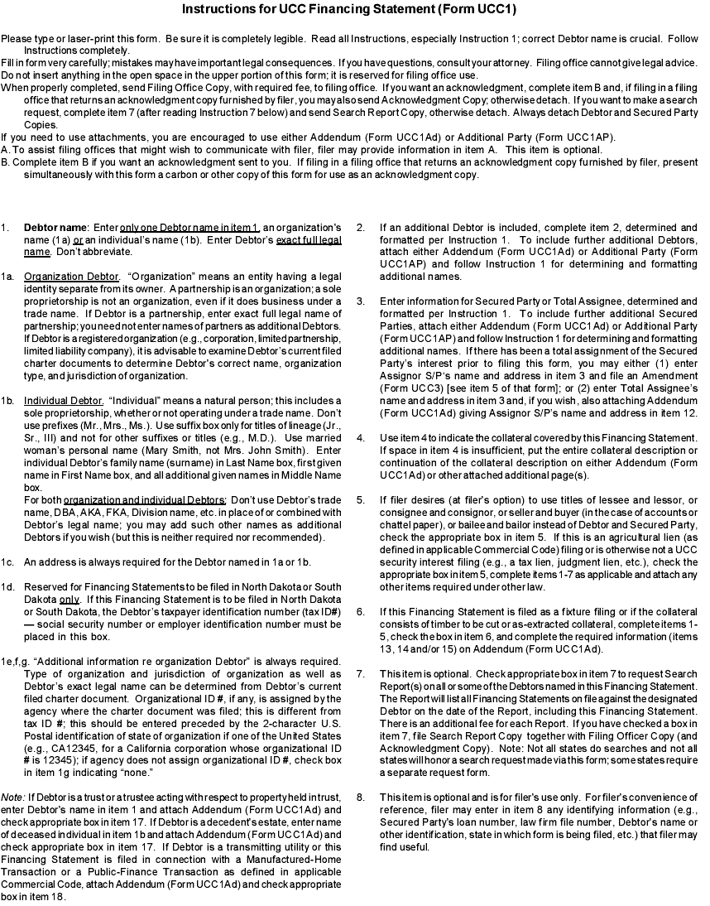

Title Guarantee, Inc.
516-222-2444

